**Logical Volume Manager**

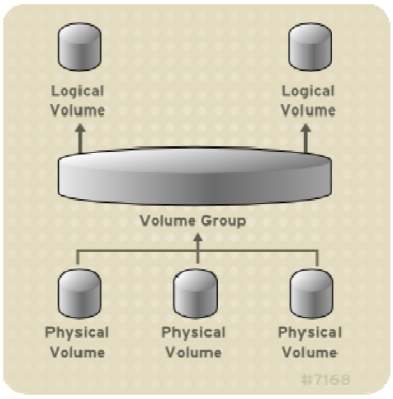

[ Creating a physical volume ]

# pvcreate /dev/sdb

[ creating partitions using ‘fdisk’ ]

# fdisk /dev/sdb

[ press ‘n’ to create a new partition]

# n

[ press ‘p’ for primary partition]

# p

[ press ‘1’ for partition number ]

# 1

[ Set the size of the partition ]

# go with default starting and ending sector value

[ press ‘p’ to print the partition table ]

# p

[ press ‘w’ to save the partition table ]

# w

[ to list the blocks ]

# lsblk

Here, you can check the created partition created.

[ creating partitions using ‘parted’ ]

# parted /dev/sdc

[ Label the partition]

# mklabel gpt

#mkpart

[ type primary or extended partition type]

# p

[ filesystem type ]

# xfs

[ Start size of the partition ]

# 1

[ End size of the partition ]

# 4000

#quit

[ to list the blocks ]

# lsblk

Here, you can check the created partition created.

[ creating multiple physical volumes ]

# pvcreate /dev/sdc /dev/sdd /dev/sde

[ Scanning for Block Devices]

You can scan for block devices that may be used as physical volumes with the lvmdiskscan command

# lvmdiskscan

[ Displaying Physical Volumes ]

# pvdisplay

[ Scanning physica volumes ]

# pvscan

PV /dev/sdb2 VG vg0 lvm2 [964.00 MB / 0 free]

PV /dev/sdc1 VG vg0 lvm2 [964.00 MB / 428.00 MB free]

PV /dev/sdc2 lvm2 [964.84 MB]

Total: 3 [2.83 GB] / in use: 2 [1.88 GB] / in no VG: 1 [964.84 MB]

The pvscan command scans all supported LVM block devices in the system for physical volumes.

[ Creating volume group ]

# vgcreate vg1 /dev/sdb1

[ Displaying volume groups ]

# vgdisplay

[ Extending volume group size ]

# vgextend /dev/vg1 /dev/sdc1 /dev/sde /dev/sdf

[ Displaying volume groups ]

# vgdisplay

[ Reducing the volume group size ]

# vgreduce /dev/sdf /dev/vg1

[ Scanning volume groups ]

# vgscan

[ Creating Logical Volumes ]

# lvcreate -L 4G -n /dev/vg1/lv1 /dev/vg1

[ creating a file system for logical volume]

# mkfs.xfs /dev/vg1/lv1

# lvdisplay

[Extending logical volumes ]

# lvextend –L +2G /dev/vg1/lv1

[ display logical volume details]

# lvdisplay

[ Reducing logical volume ]

# lvreduce –L -2G /dev/vg1/lv1

[ display logical volume details]

# lvdisplay

[ Removing logical volumes ]

# lvremove /dev/vg1/lv1 /dev/vg1

[ check the size of the volume group ]

# vgdisplay